1. Login to JFR
2. Click Appt Actions; the system transfers control to the Appointment Actions screen
3. Click New Appointment Action at the bottom of the screen; the system transfers
control to the Create New Request screen.
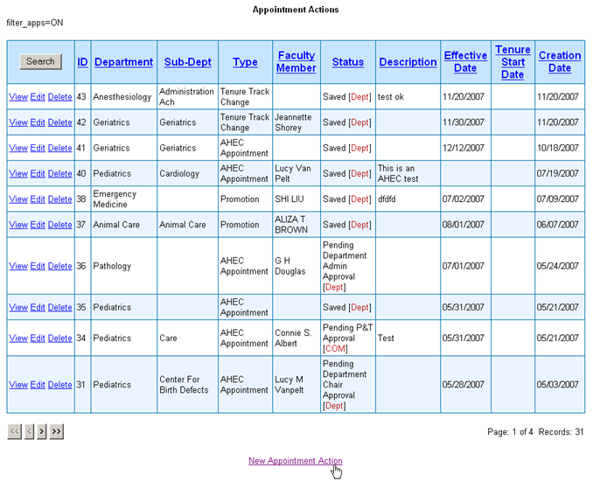

4. Complete the fields on the Create New Request screen; selecting Type: Tenure Track
Change
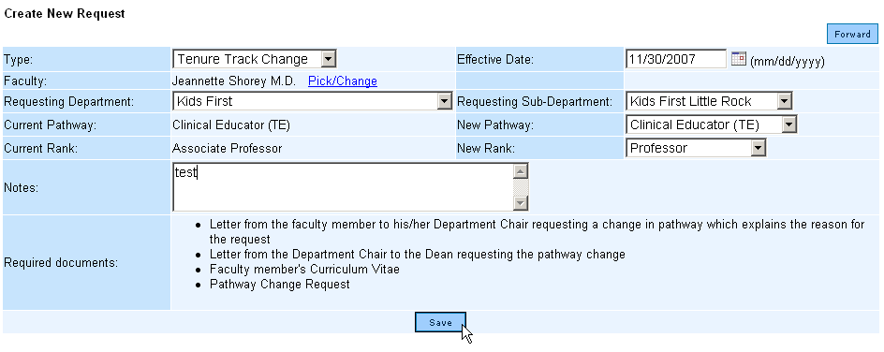

5. Click Save to save the record. The system transfers control to the View Request Details screen

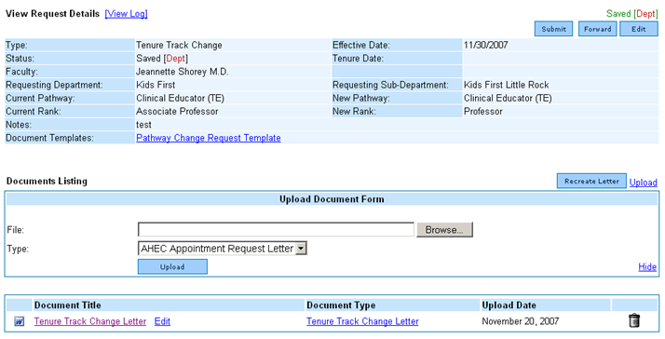

6. Click on Document Templates: Pathway Change Request Template

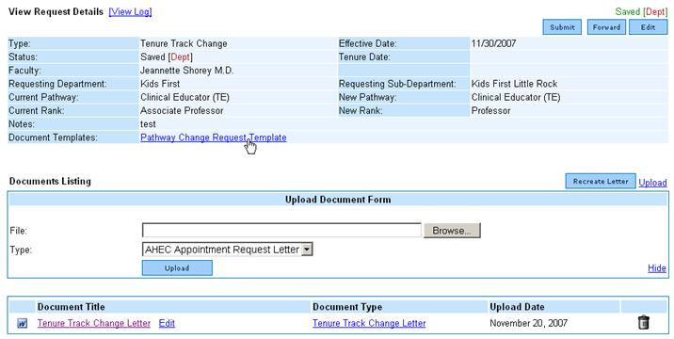

7. When the window opens asking if you want to OPEN or SAVE the document, click SAVE and select the location on your local machine for the file to be stored. The file will be downloaded to the location selected.

8. Open the Pathway Change Request file and complete the form. (Note: 2-page form)

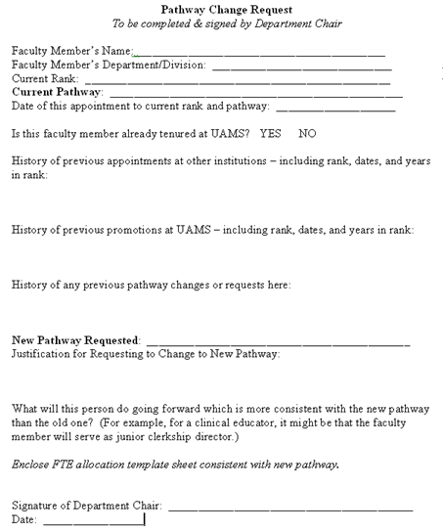

9. Upload the completed Pathway Change Request document on the View Request
Details screen under Upload Document Form section selecting Type: Pathway Change
Request.

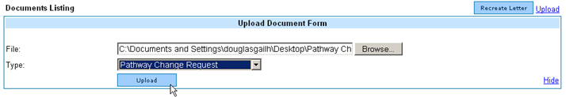
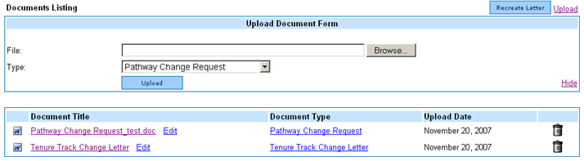

10. Download the applicable Financial Billing Plan and save to your desktop. (The Financial Billing Plan Template can be accessed from the View Request Details screen or on Useful Links.) Retain the tab (sheet) for the new track; delete all other tabs (sheets) in the workbook. Complete the form.

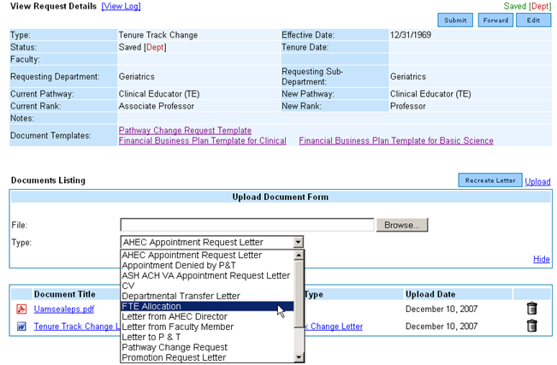

11. Upload the completed FTE Allocation Form selecting TYPE: FTE Allocation Form.

12. Upload a current CV as an attachment selecting the TYPE: CV.

